Tables
Table 1.
Frequencies for In-laws Abuse (N=468)

Item | Overall Frequency | Frequency for Male Participants | Frequency for Female Participants
Interference about whereabouts by in-laws | 56.7 | 55.3 | 57.8
Interference over financial matters by in-laws | 60.3 | 56.1 | 63.5
Demeaning tone used by in-laws | 65.3 | 59.1 | 71.7
Physical harm by in-laws | 69.1 | 63.6 | 74.8
*Total men in the sample= 198
*Total women in the sample= 252
*Number of male and female participants do not total 468 due to some missingness.

Table 2.
Exploratory Factor Analysis Results for the Overall Sample

Item | Overall Factor Loading
Interference about whereabouts by in-laws | 0.90
Interference over financial matters by in-laws | 0.92
Demeaning tone used by in-laws | 0.94
Physical harm by in-laws | 0.83

Table 3.
Exploratory Factor Analysis Results for Male Participants

Item | Factor Loading
Interference about whereabouts by in-laws | 0.87
Interference over financial matters by in-laws | 0.91
Demeaning tone used by in-laws | 0.93
Physical harm by in-laws | 0.84

Table 4.
Exploratory Factor Analysis Results for Female Participants

Item | Factor Loading
Interference about whereabouts by in-laws | 0.91
Interference over financial matters by in-laws | 0.93
Demeaning tone used by in-laws | 0.94
Physical harm by in-laws | 0.81

Appendix A

Figure 1. Figure 2.
Scree Plot for Overall Participants Scree Plot for the Male Participants (N=468)

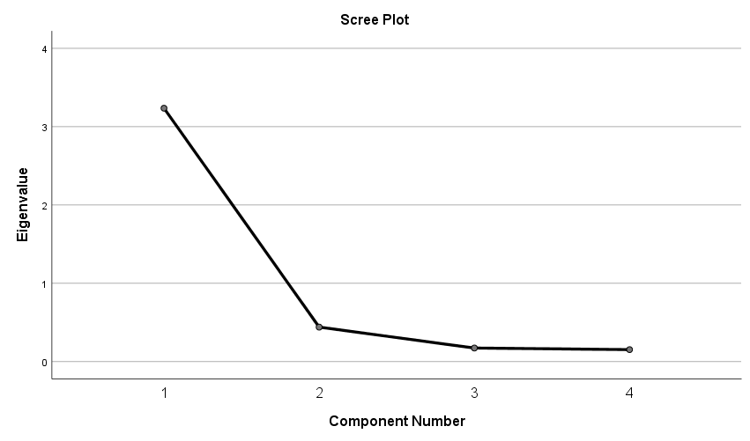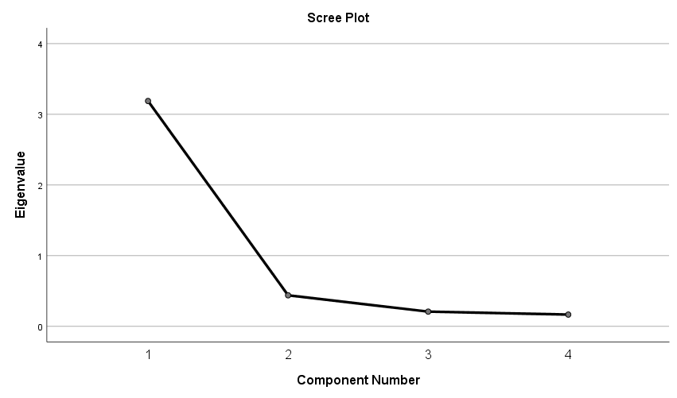

Figure 3.
Scree Plot for Female Participants

