RESEARCH ARTICLE

Widening participation students’ experience and perception of flipped learning statistics compared with traditional teaching

Table 1. Modes of teaching in M1 and M2 in the 2021-22 academic year.
Statistics content | M1 | M2 | Assessment
Term 1 (10 weeks): Descriptive analysis | FL | TT | Open book
Term 2 (10 weeks): Inferential analysis | TT | FL | Open book

Table 2. Performances on the statistics of the students in 2021-22
Group* | M1  (n=30) | M2  (n=20) | M1  (n=23) | M2  (n=16)
Average of the GCSE at entry of the study  (Standard deviation) | 5.5  (1.47) | 5.6  (1.49) | 5.3  (1.81) | 5.7  (1.57)
Assessment content | Descriptive statistics |  | Inferential analysis
Average mark (%) | 73.9  (s.d.=16.0)  (FL) | 73.7  (11.0)  (TT) | 73.5  (20.1)  (TT) | 67.3  (17.4)  (FL)
p-value (Two sample independent t-test) | 0.957 |  | 0.313
Cohen’s effect size | 0.016 |  | 0.333
* Only the students that completed the tests were included in the averages.

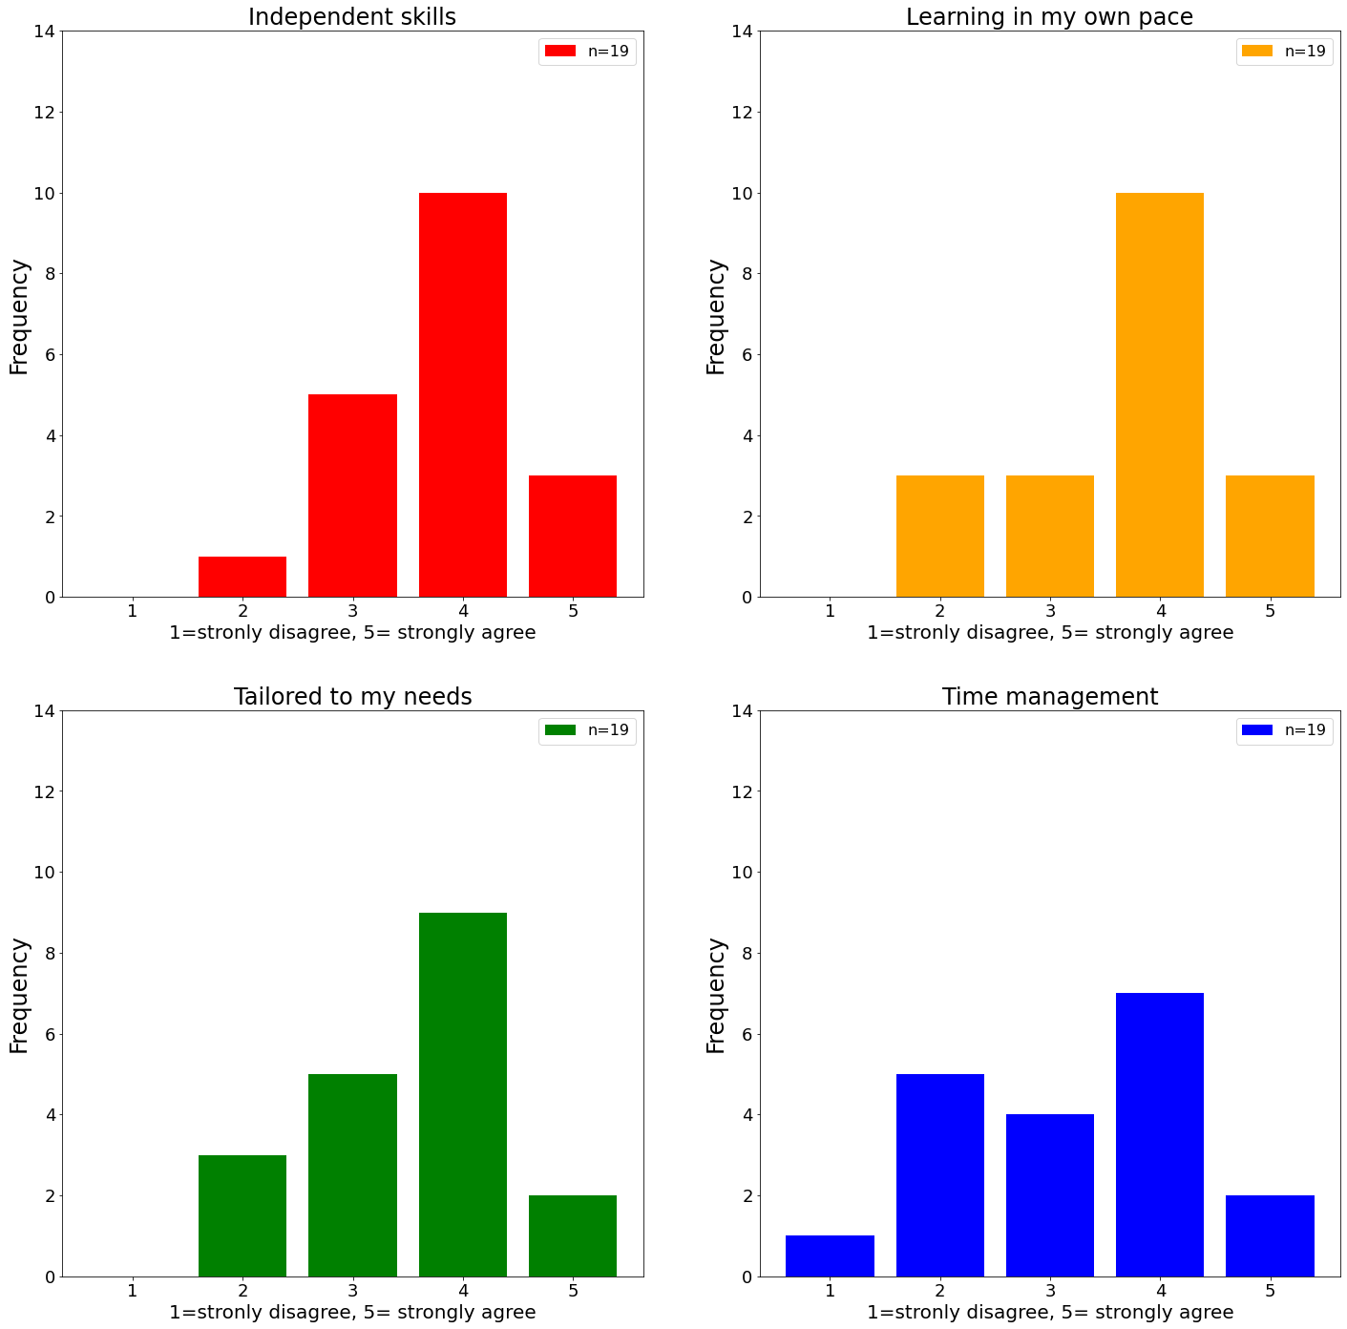
Figure 1. Students’ response to the questionnaire regarding study skills

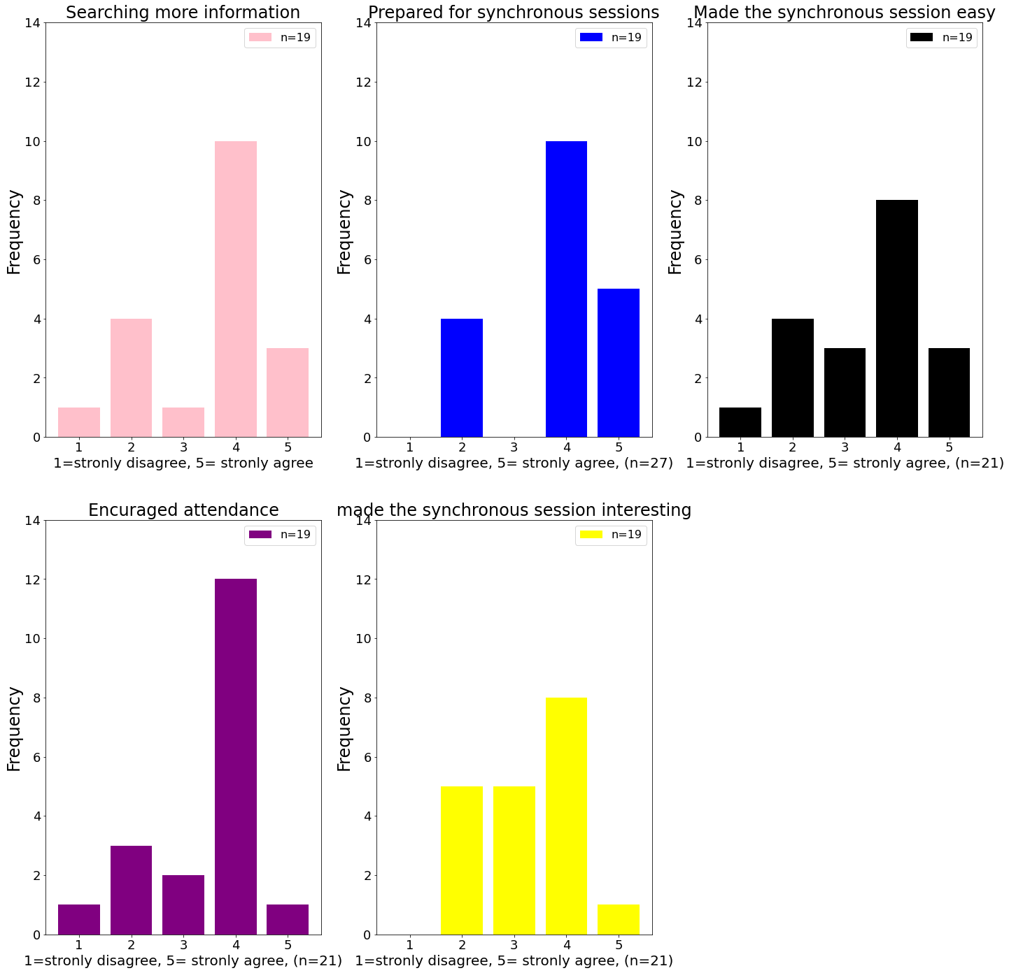
Figure 2. Students’ response to the questionnaire regarding emotional and cognitive engagement
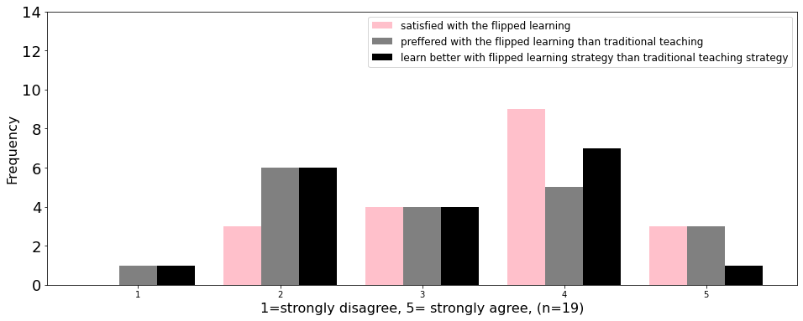
Figure 3. Students’ response to the questionnaire regarding overall experience for FL

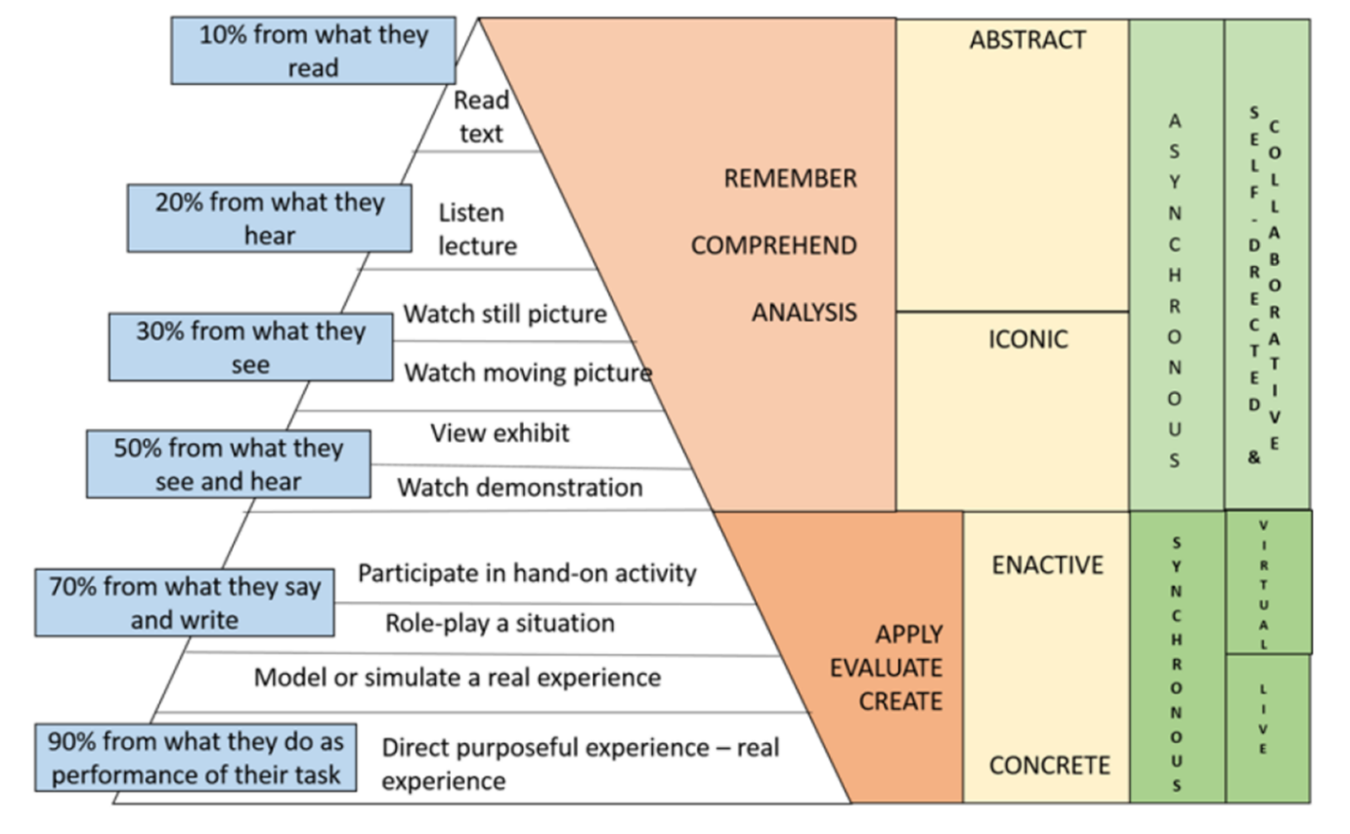
Figure 4. Model of criteria for determining appropriate blended learning strategy (Chaeruman et al., 2018)

