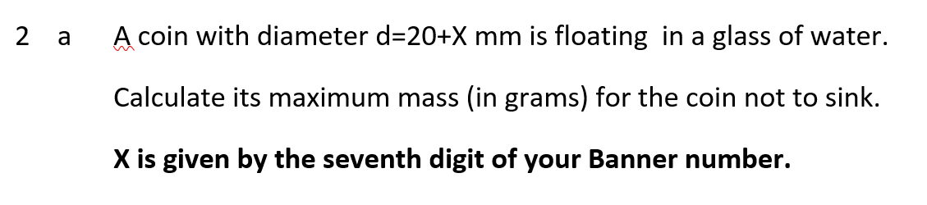
Figure 4. (Top) A question posed in a remote examination which is individualised, in part, using the student’s Banner (matriculation) number, and (bottom) a request for a solution to said question, alongside a student’s Banner number on coursehero.com.

